产品名称：T100G-3履带推土机
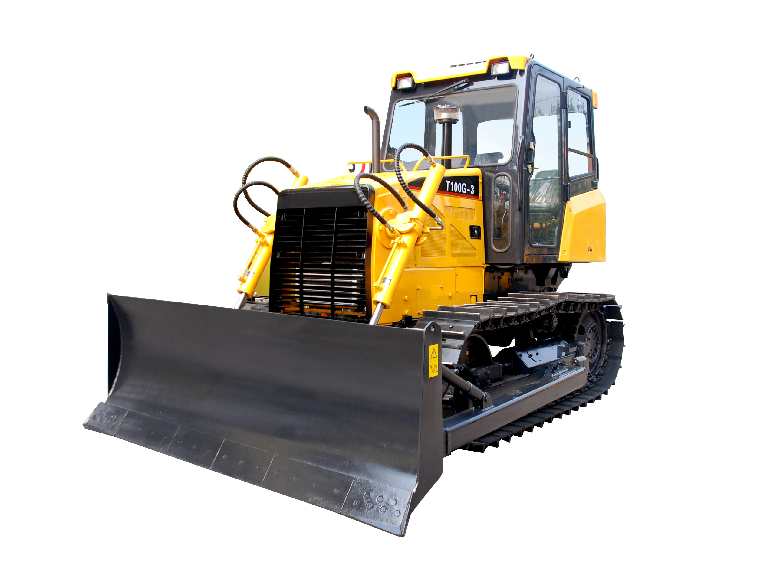
产品参数：×
型号 | Model | Unit | T100G-3
整机重量 | Total weight | kg | 10400
最大牵引力 | Max towing force | kN | 95
发动机型号 | Engine model |  | LR6A3LU23/0810E
发动机标定功率/转速 | Engine rated power /speed | kw/ r/min | 81/2300
发动机燃油消耗率 | Fuel consumption of the engine | g/km.h | ≤220
发动机最大扭距 | Engine max torque | N.m | 414
前进1-4档 | Forward 1-4 gear | km/h | 2.6～10.4
后退1-2档 | Reverse 1-2 gear | km/h | 3.7～6.7
履带宽度 | Caterpillar track board width | mm | 450
接地比压 | Land pressure | kPa | 54.4
外型尺寸(长×宽×高) | Overall dimension(L×W×H) | mm | 4190×2935×3020
推土铲(宽×高) | Bulldozer shovel（W×H） | mm | 2935×960
铲刀最大提升高度 | Blade max lifting height | mm | 830
铲刀入土深度 | Blade max digging depth | mm | 350
牵引装置/松土器(选装) | Towing equipment/Ripper(optional) |  | 摆动式/三齿

产品说明：
1、本机采用与英国里卡多公司合资技术生产的柴油发动机，符合国家Ⅲ阶段排放要求，噪音低、扭距大、节能环保；
2、采用干式、多片结构、常结合主离合器，具有扭距储备大，工作可靠等特点；
3、变速箱为4F﹢2R机械换档变速箱，操作简单，维修方便，使用可靠；
4、转向离合器为干式，多片转向离合器，液压助力操纵，易保养，操纵轻便；
5、传动：采用两级、直齿、大模数齿轮传动，具有承载能力强，可靠性高等优点；
6、采用豪华驾驶室，顶置式空调系统，操作空间舒适；
7、可选装直倾铲、角铲、煤铲等多种工作装置可供用户根据需要选择。

1、Engine: Choose the engine produced with British Ricardo joint-venture technology, which conforms to National Ⅲ emission standard, and features low noise, large torque, energy efficient and environmental friendliness.
2、Main clutch: Choose dry, multi-disk and constant combining clutch which features big torque reserve and high reliability.
3、Gearbox: Choose 4F+2R mechanical gear-shifting gearbox, simply operating, conveniently maintaining, reliably using.
4、Steering clutch: Choose dry and multi-disk turning clutch, manually operating with hydraulically-assisted, easily maintaining, lightly and conveniently operating.
5、Transmission: Choose two stages, straight teeth, big modulus gear transmission, stronger carrying capacity, and higher reliability.
6、Cab: Adopt the luxury cab, overhead air-conditioning system, comfortable operating space.
7、Optional work device: Straight-tilt shovel, angle shovel， coal shovel and so on.

