产品名称： T80-3履带推土机
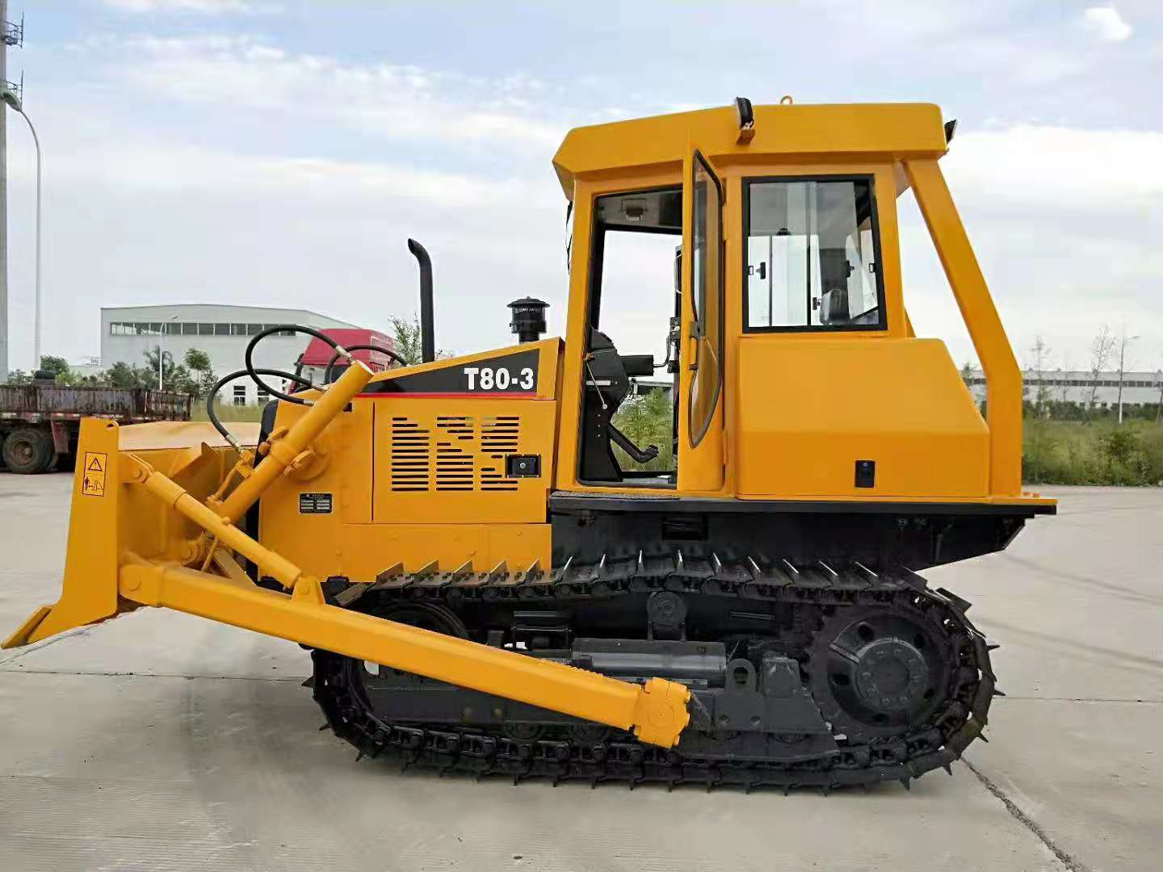
产品参数：
型号 | Model |  | T80-3
整机重量 | Total weight | kg | 8600
最大牵引力 | Max towing force | kN | 82
发动机型号 | Engine model |  | LR4A3ZU22/0662
发动机标定功率/转速 | Engine rated power /speed | kw/ r/min | 66.2/2200
发动机燃油消耗率 | Fuel consumption of the engine | g/kw.h | ≤225
发动机最大扭距 | Engine max torque | N.m | 345
前进1-4档 | forward 1-4gear | km/h | 2.4～10.4
后退1-2档 | Reverse 1-2 gear | km/h | 4.9～8.9
履带宽度 | Track board with | mm | 400
接地比压 | Land pressure | kPa | 51
外型尺寸(长×宽×高) | Overall dimension(L×W×H) | mm | 4200×2480×2740
推土铲(宽×高) | Bulldozer shovel（W×H） | mm | 2480×922
铲刀最大提升高度 | Blade max lifting height | mm | 736.5
铲刀最大入土深度 | Blade max digging depth | mm | 370
切土角（可调） | Cutting angle(adjustable) | ° | 55
牵引装置/松土器（选装） | Twing equipment/Scarifier(Optional) |  | 固定式/三齿

产品说明：
1、本机使用东方红LR4A3ZU22/0662型增压发动机，动力大，噪音低，节能低耗；
2、变速箱为4F﹢2R定轴式机械换档变速，适应多种环境作业；
3、采用半刚性悬架、整体台车行走结构；
4、先进的控制操纵系统，全液压助力转向，操纵灵活省力；
5、驾驶室由型钢焊接构成，强度高，耐冲击，防护安全性好；
6、适用于狭小地块环境施工，工作灵活，作业效率高；
7、标配暖风装置，选装冷暖两用空调；
8、整机的保养点采用人性化设计，提高了保养、维修的方便性；
9、整机动力经济性好，可靠性高，是工程施工的理想机械。

1、The machine is installed with the YTO LR4A3ZU22/0662 boosting engine, with high power, low noise, energyconservation and low consumption.
2、Gearbox is 4F+2R fixed-shaft mechanical gear shifting.applicable for various environments.
3、Integral trolley traveling construction adopting semi-rigid. Semi-rigid hanger.
4、Advanced operation control system,fully hyd raulic aided steering,with flexible and labor-saving operation.
5、Driver cab is welded with profile steel, with highstrength, resistant against impact, andgood prolection safety.
6、Applicable for construction in narrow ground,with flexible working and high operationefficiency.
7、Standard heating and ventilation equipment, airconditioner optional.
8、Each maintenance center has humanizeddesign, improving the convenience of repair andmaintenance.
9、The complete machine has good economicalpower and high reliability, being an ideal machinefor project construction.

