產 品 規 格 承 認 書
SPECIFICATION FOR APPROVAL

客戶名稱
CUSTOMER
產品名稱  PRODUCT NAME | 玻璃慢断保险丝
型號規格  MODEL DETAIL | 3GTU
承认日期
APPROVAL DATE

編制 | 經理 | 業務
PREPARED | MANAGER | OPERATION
陈兰欣 | 陈奕霖

承認 | 審核 | 批准
SIGNATURE | CHECKED BY | APPROVAL BY

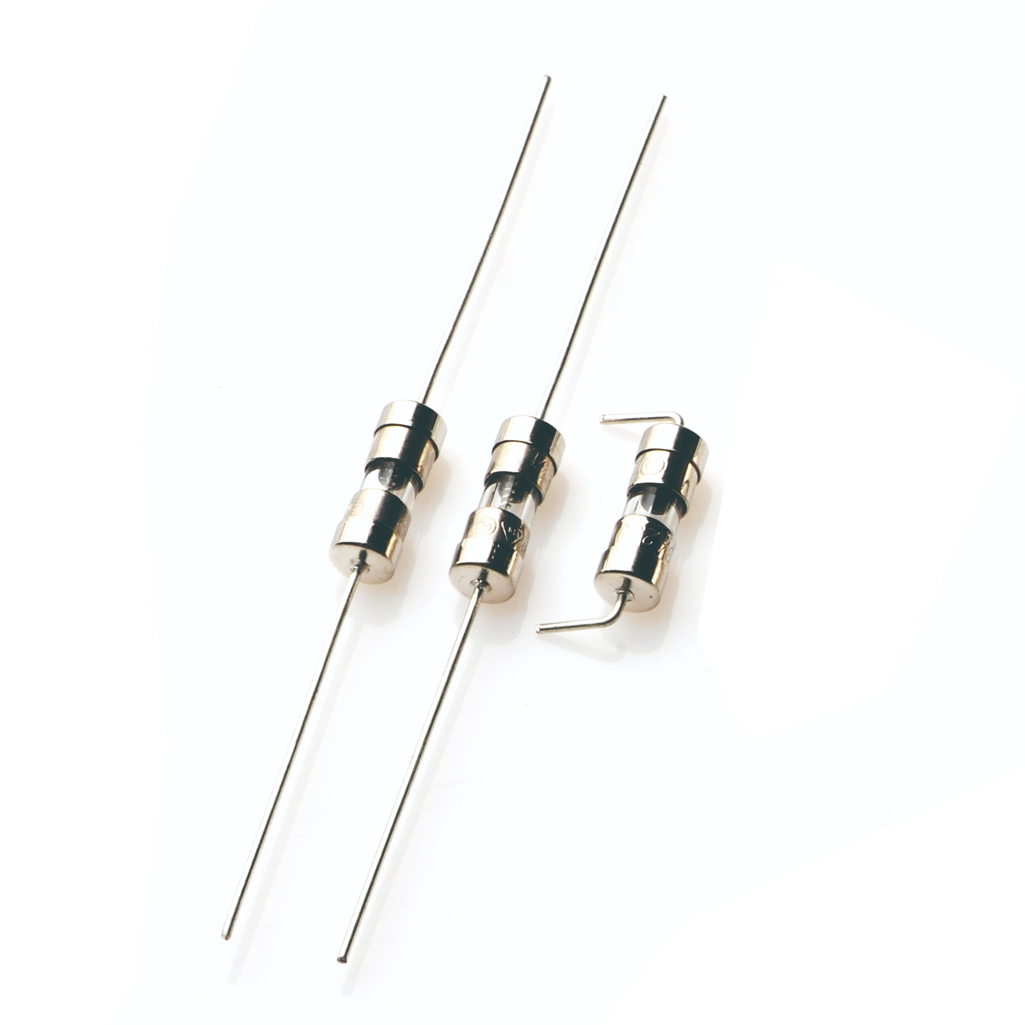
1.規格型號和安規認證
MODEL NUMBER AND SAFETY CERTIFICATION
品名規格：系列號+額定電流+額定電壓+認證符號
Model Number: Part Number+Rated Current+Rated Voltage+Approvals.
例子[example]:
3GTU， 2A， 250V
1)系列號 Part Number，2)額定電流 Rated Current，3)額定電壓 Rated Voltage

1-2 額定電流和額定電壓 Rated Current And Voltage
額定電流：100mA~10A Rated Current: 100mA~10A
額定電壓：250V AC Rated Voltage:250V AC
1-3 標示 Marking
保險絲上需有下列標示 The fuse shall have the following marking:
規格：特性符號+額定電流+額定電壓 Specification:Characteristic Symbol+Rated Voltage
100mA~800mA : _mA250V 1A~10A: _A250V
Trade mark:The Manufacture’s Logo+Part Number+Approvals

100mA~10A:
注意：對標示字樣大小沒有規定
Note:Size of the markings have not be specified.

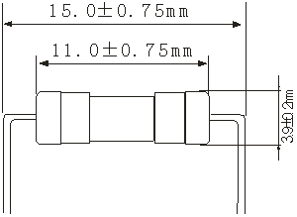
3-2 結構 Structure

編號No. | 元件Component | 材質Material | 數量Quantity
1 | 熔絲 Wire | 合金 Alloy | 1
2 | 銅帽 Cap | 黃銅鍍鎳 Brass with mickel plated | 2
3 | 本體 Body | 玻璃管 GLASS Tube | 1
4 | 引線 Lead | 鍍錫銅線 Tinned Copper wire | 2

2.適用範圍 SCOPE
適用於一般電子設備。Used in electronic equipment.

3.工程圖和結構 OUTLINE DRAWING AND STRUCTURE
3-1 工程圖（單位：mm）Outline Drawing and Dimensions(Unit:mm)
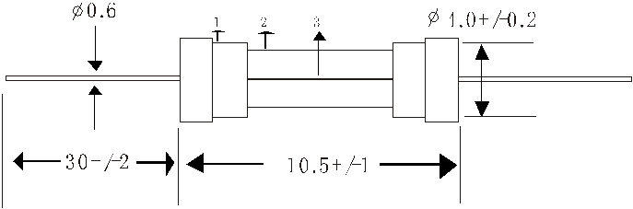

4.外觀及形狀
4-1 外觀：不應有破碎、明顯的汙斑

4-2 形狀：帶腳的保險絲

5.物理特性
5-1 拉力測試
沿端子的軸向施加 10N 的拉力，持續 1 分鐘。

4.APPEARANCES AND CONFIGURATION
4-1 Appearances:There shall no fragmentation and of remarkable blotch.
4-2 Configuration:Axial Leaded Fuse.

5.PHYSICAL CHARACTERISTIC
5-1 Tensile test
Keep pulling the cap of the fuse with 10N at axial direction for 1 min.
6.電氣特性
ELECTRICAL CHARACTERISTICS
熔斷/電流特性：
Acting Time/Current Characteristic
- Breaking capacity（分断能力）(Time Lag and Fast Acting)

50A 250V AC

b、Electrical characteristics
Time Lag

c、Temperature character
当100%的电流下温度上升不超过75℃
When 100% of rating the temperature rise doesn’t exceed 75℃.
Rated current | % of Ampere | Opening Rating Time
100mA~ 10A | 100% | 200%
100mA~ 10A | 4 hours, Minimum | 60 seconds, Max.

Catalog Number | Rating Ampere（A） | Rating Voltage（V） | Nominal Cold  Resistance  (Ohms) | Nominal  Melting I2t (A2 sec) | Agency Approvals
 |  |  |  |  | UL | CSA | CQC
3GTU-.100 | .100 | 250V | 7.5300 | 0.00250 | x | x | x
3GTU-.125 | .125 | 250V | 2.9850 | 0.00370 | x | x | x
3GTU-.200 | .200 | 250V | 2.5280 | 0.0161 | x | x | x
3GTU-.250 | .250 | 250V | 1.7700 | 0.0252 | x | x | x
3GTU-.300 | .300 | 250V | 1.1880 | 0.0332 | x | x | x
3GTU-.400 | .400 | 250V | 0.3140 | 0.0735 | x | x | x
3GTU-.500 | .500 | 250V | 0.2250 | 0.137 | x | x | x
3GTU-.600 | .600 | 250V | 0.1550 | 0.482 | x | x | x
3GTU-.800 | .800 | 250V | 0.1120 | 0.949 | x | x | x
3GTU-001 | 1.00 | 250V | 0.0940 | 1.22 | x | x | x
3GTU-01.5 | 1.50 | 250V | 0.0515 | 3.52 | x | x | x
3GTU-01.6 | 1.60 | 250V | 0.0494 | 3.75 | x | x | x
3GTU-002. | 2.00 | 250V | 0.0410 | 6.56 | x | x | x
3GTU-02.5 | 2.50 | 250V | 0.0344 | 9.19 | x | x | x
3GTU-003. | 3.00 | 250V | 0.0247 | 18.4 | x | x | x
3GTU-004. | 4.00 | 250V | 0.0191 | 28.6 | x | x | x
3GTU-005. | 5.00 | 250V | 0.0114 | 58.6 | x | x | x
3GTU-006. | 6.00 | 250V | 0.0095 | 77.2 | x | x | x
3GTU-007. | 7.00 | 250V | 0.0084 | 94.7 | x | x | x
3GTU-008. | 8.00 | 250V | 0.0077 | 114.0 | x | x | x
3GTU-010. | 10.0 | 250V | 0.0070 | 224.0 | x | x | x

Average Time Current Curves
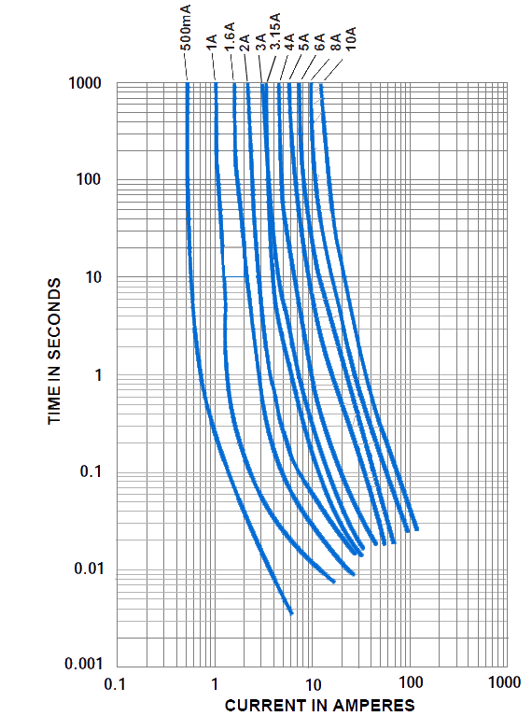

7.環境特性
7-1 操作溫度範圍：-5℃~60℃
7-2 保存條件
溫度：+10℃~60℃
在相對濕度≤75%下平均可存放 3 年
在非露天下，相對濕度為 95%下最多可存放 30 天。

8.焊接條件
8-1 波峰焊
焊接溫度：260±5℃
焊接時間：4 Sec. Max.
8-2 手工焊錫
焊接溫度：350±5℃
焊接時間：3 Sec. Max.

9.其他使用注意事項
如果需在保險絲上加熱縮套管，烘烤溫度與時間需參照以下規定
設定烘烤溫度：不大於 150℃ 烘烤時間：50s Max.

7.ENVIRONMENTAL SPECIFICATION
7-1 Operating Temperature: -5℃~60℃
7-2 Storage Conditions
Temperature: +10℃~60℃
On average, It can be stored below the relative humidity or 75% for 3 years.
Without dew, It can be kept under humidity of 95% for 30 days.

8.SOLDERING PAAMETERS
8-1 Wave Solder
Soldering Temperature:260±5℃
Soldering Time:4 Sec.Max.
8-2 Manual Solder
Soldering Temperature: 350±5℃
Soldering Time: 3 Sec. Max.

9.OTHER NOTICE IN USING
If heat shrink tubing was needed,the roast temperature and time should be refer to the following.
The temperature should be sel under 150℃,roast time:50s Max.

