
Office Address: No.6 Qifeng road, Ouhai District South Baixiang ,Wenzhou city, China
Mobile:0086-13456058878 E-mail: adawin@huayaocnc.cn
Website:www.wzhuayao.com

SPARE PART LIST

NO. | Product Name | PICTURE | PRICE
1 | Cutting Pad | 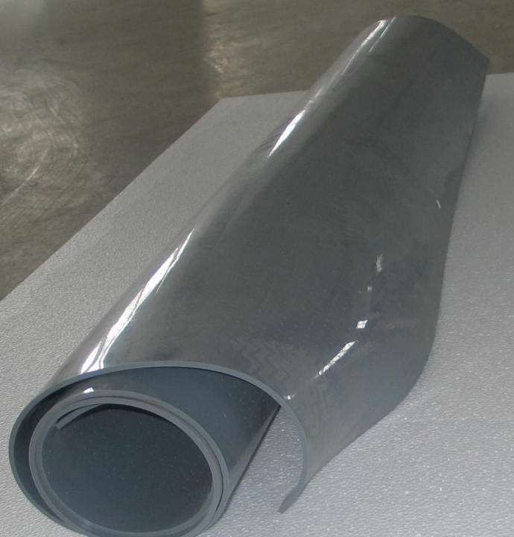 | $250~$480/piece ( according to the different model)
2 | Laser Lamps | 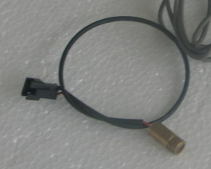 | $17/piece
3 | Proximity Switch | 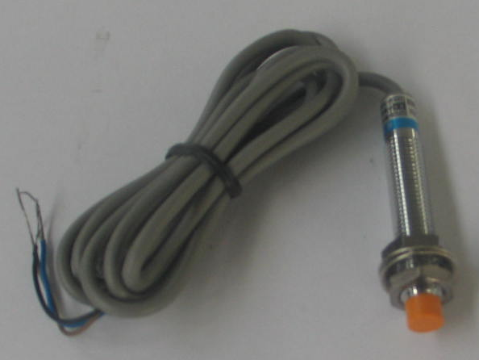 | $17/piece
4 | Optical couple sensor | 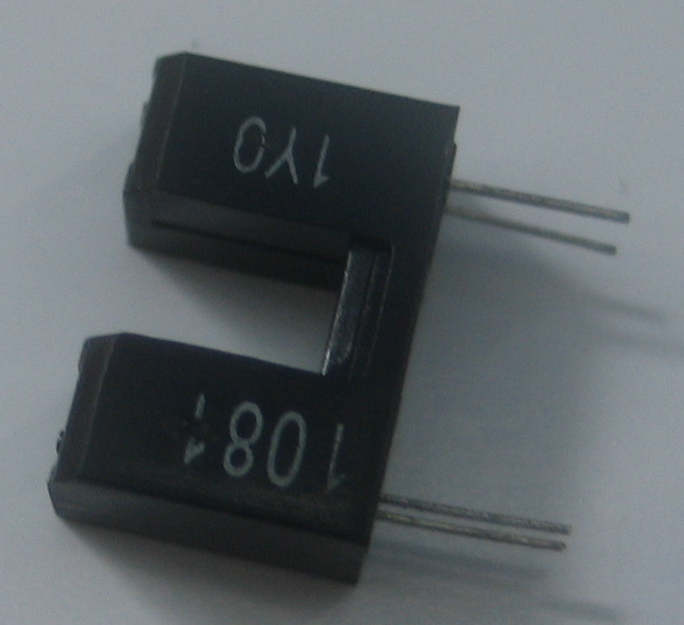 | $13/piece
5 | Solenoid Value | 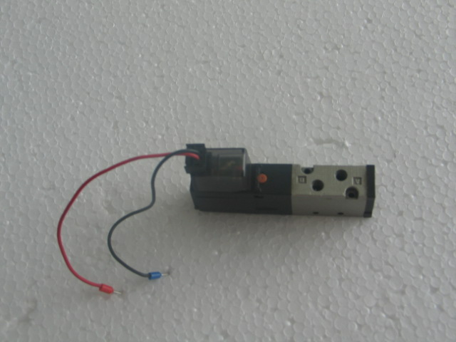 | $42/piece
6 | Gas-type fitting | 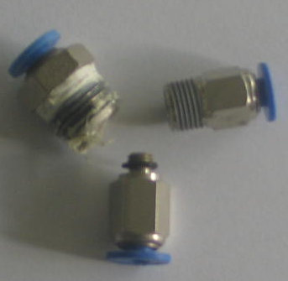 | $1.7/piece
7 | Servo Motor and Drive | 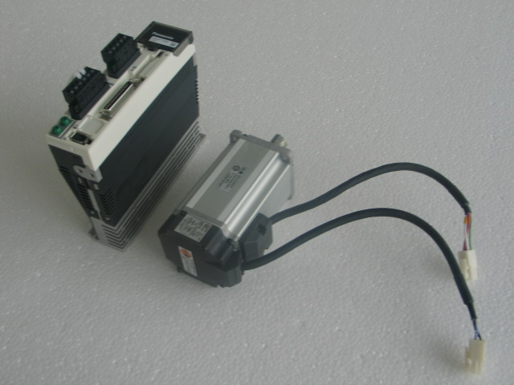 | $750~$890
8 | Stepper motor | 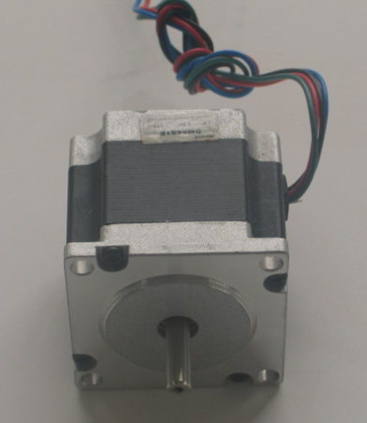 | $250/piece
9 | 24V High-Speed DC Motor | 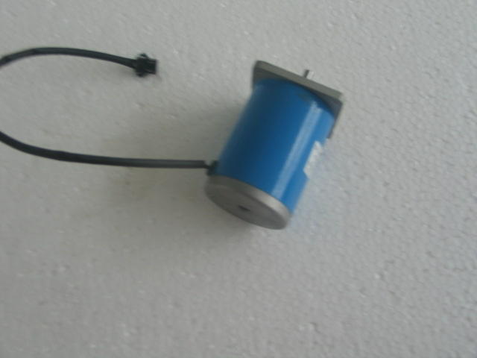 | $50/piece
10 | Blade Cover | 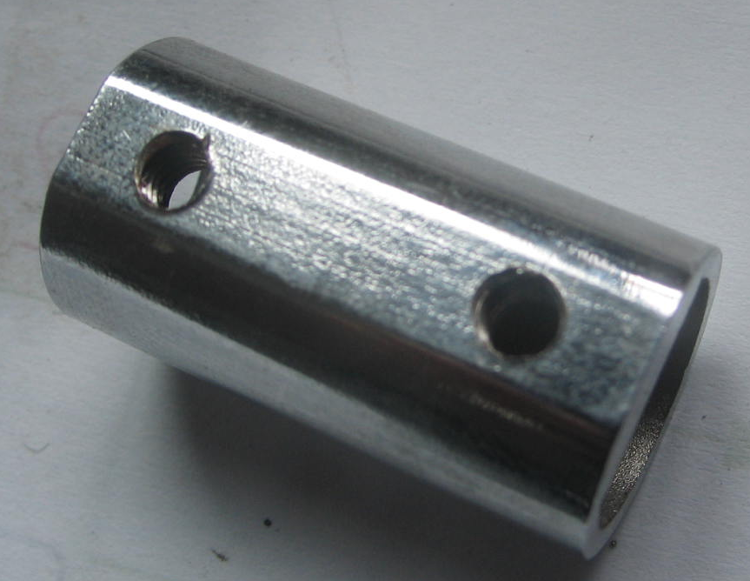 | $17/piece
11 | Wheel spindle | 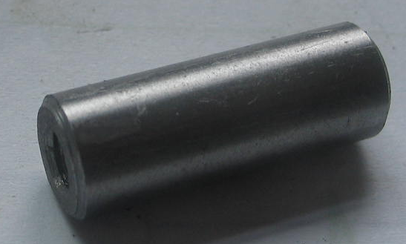 | $50/ 3 Pieces
12 | Knife spindle | 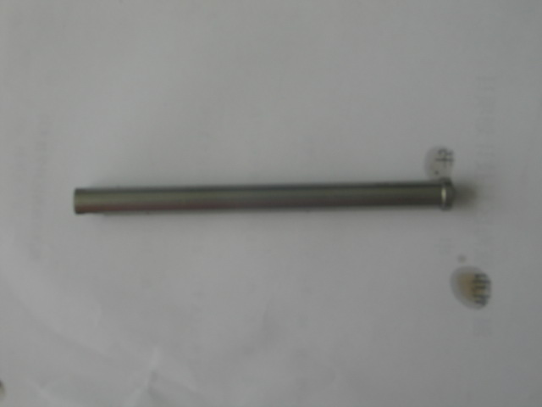 | $80/piece
13 | Knife back bear | 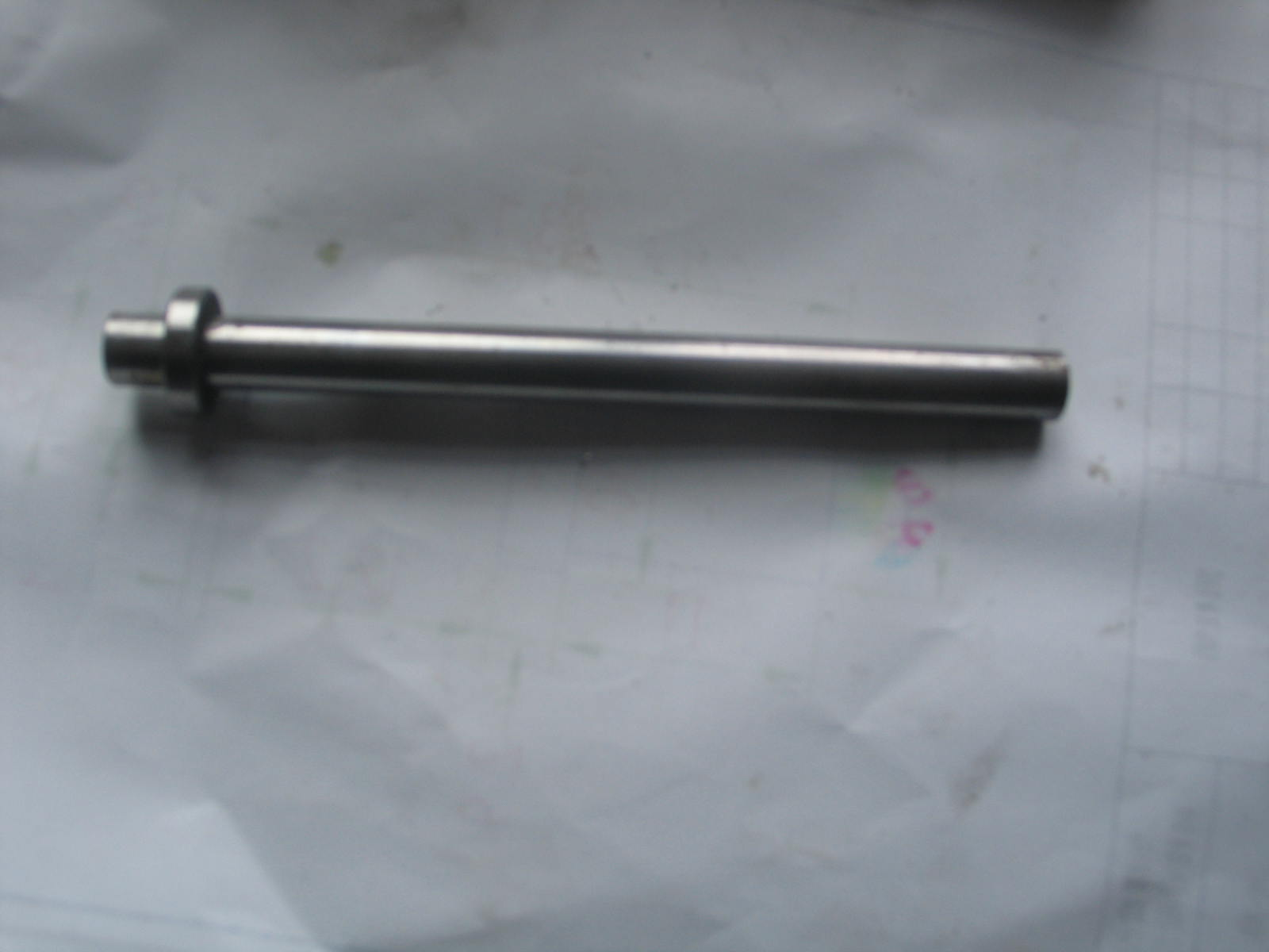 | $20/piece
14 | Cylinder | 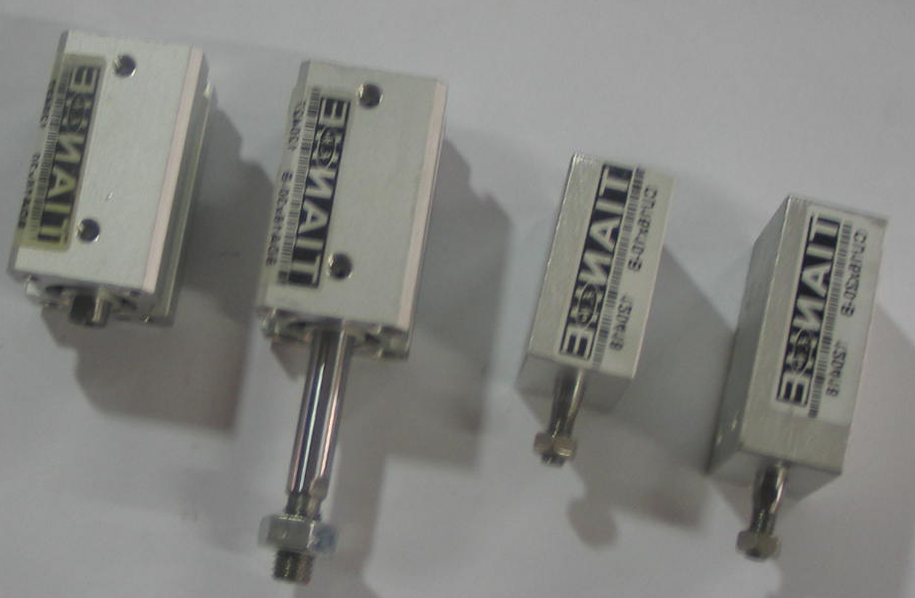 | $17/piece
15 | Eccentric Spindle | 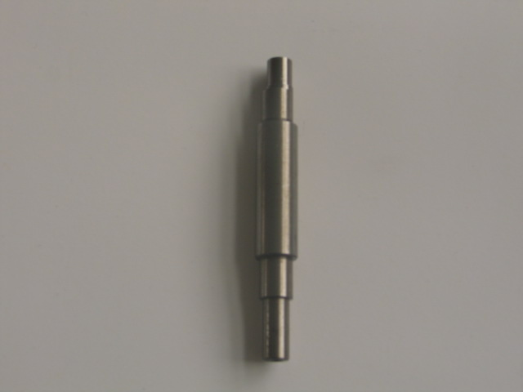 | $50/piece
16 | Slipper Block | 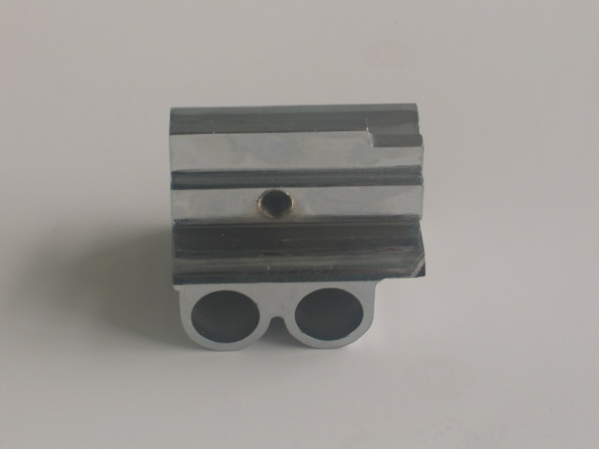 | $50/piece
17 | Imported Bear | 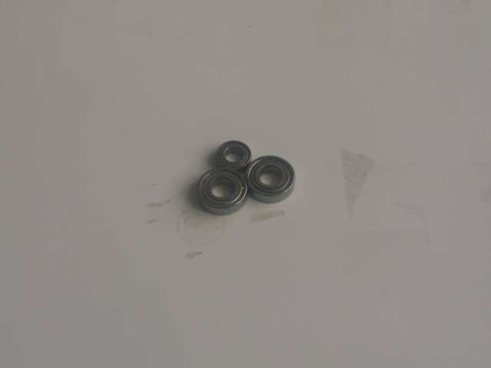 | $17/piece
18 | ￠12 Guide Pole | 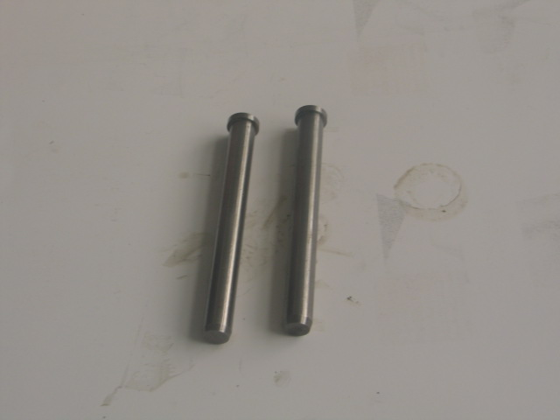 | $17/piece
19 | Connecting Rod | 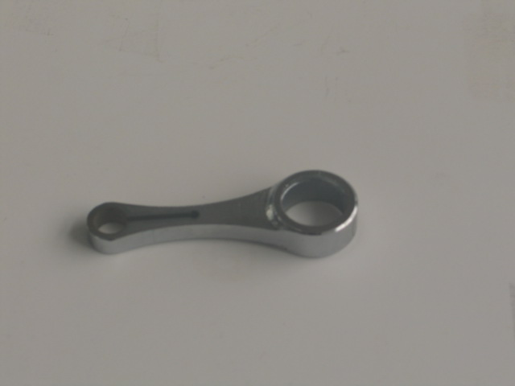 | $13/piece
20 | Penholder | 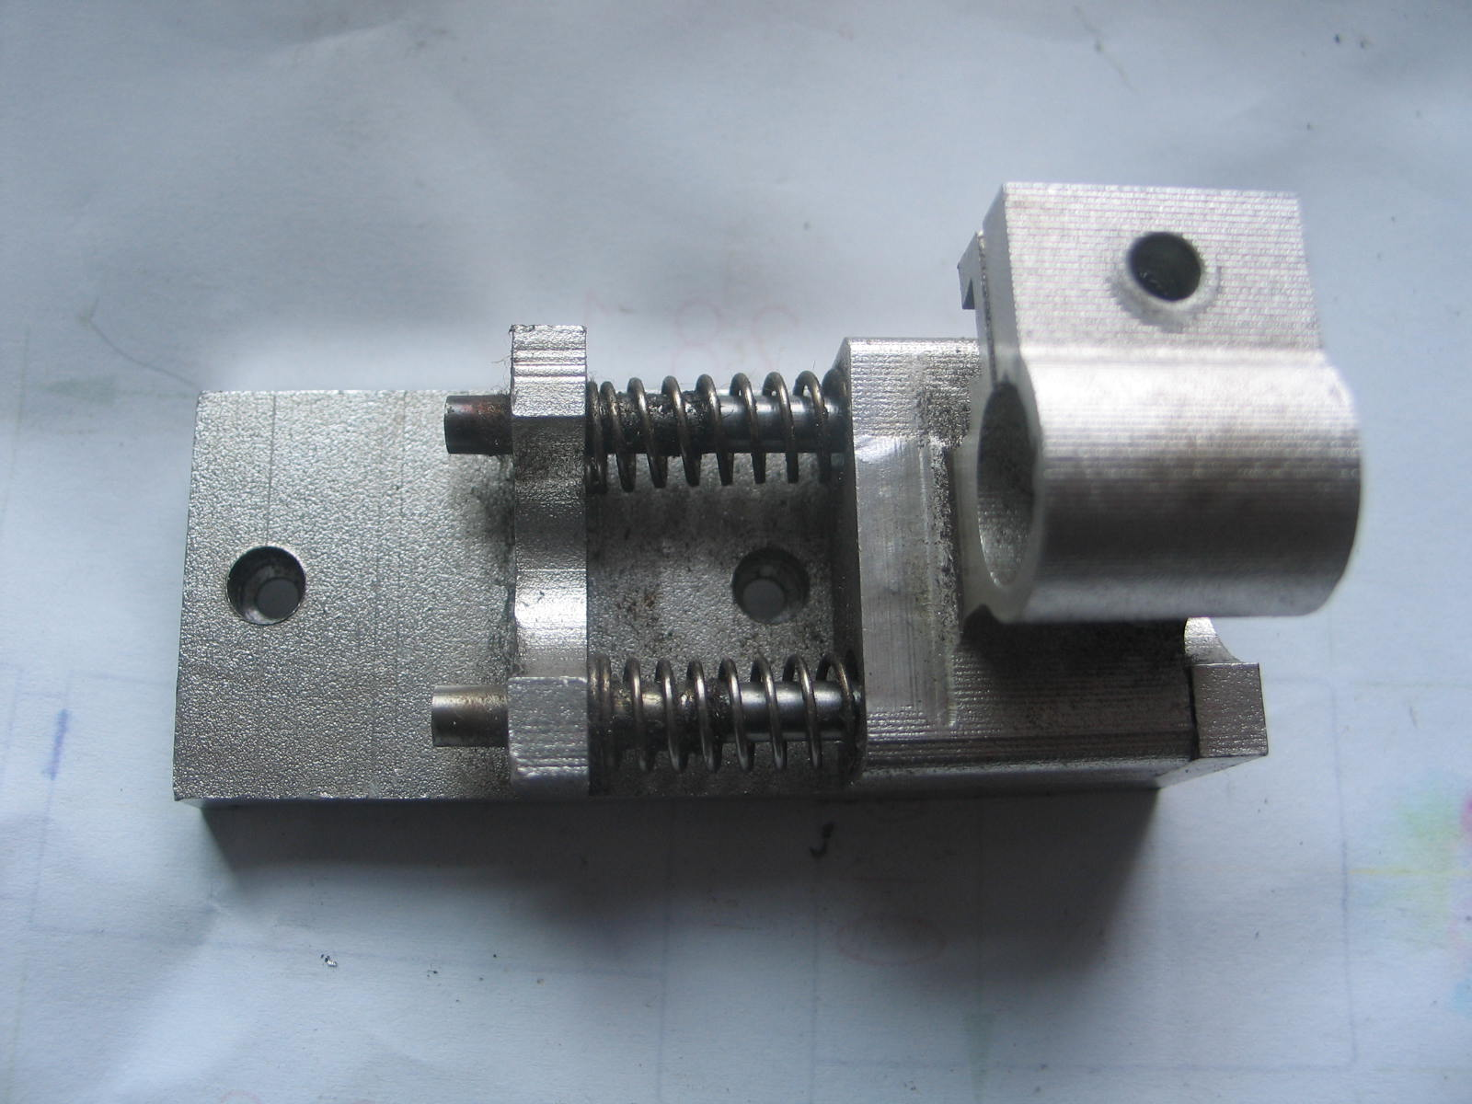 | $20/piece
21 | Circuit Board | 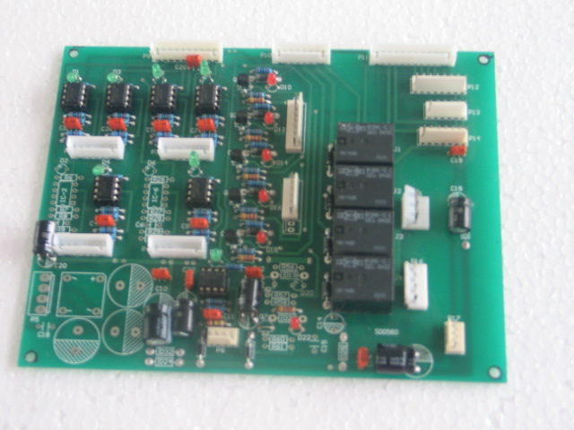 | $85/piece
22 | Pressure Reducing Valve | 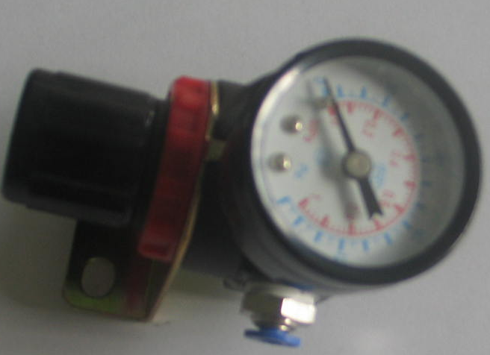 | $10/piece
23 | Strainer | 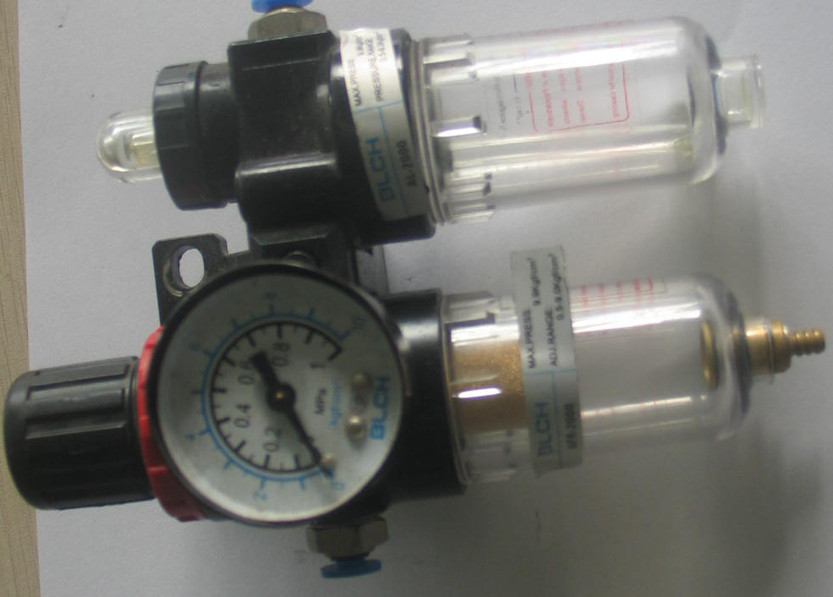 | $17/piece
24 | Fliter | 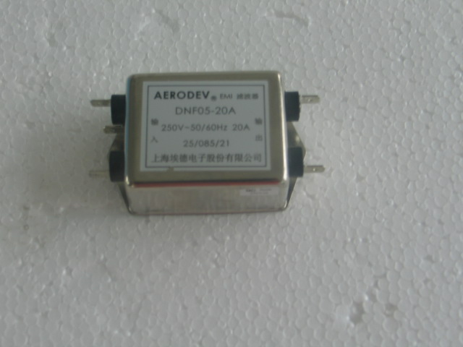 | $17/piece
25 | Control Card | 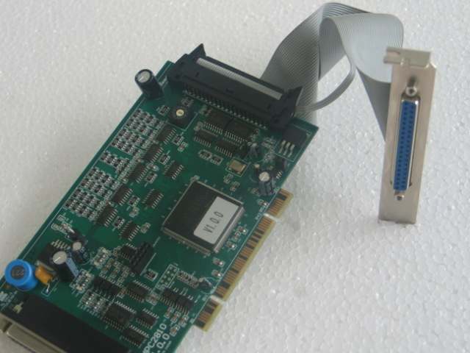 | $810/piece
26 | Pinch rollers | 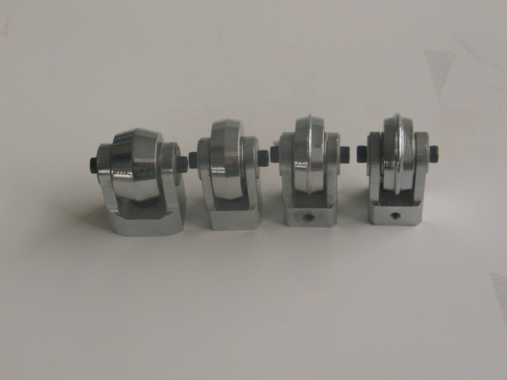 | $49/piece
27 | Belt | 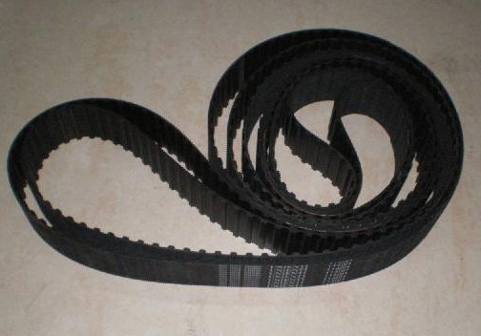 | $9/meter

